## JavaScript Video Quickstarts

Launched Twilio Video Javascript Quickstarts : <http://localhost:3000>

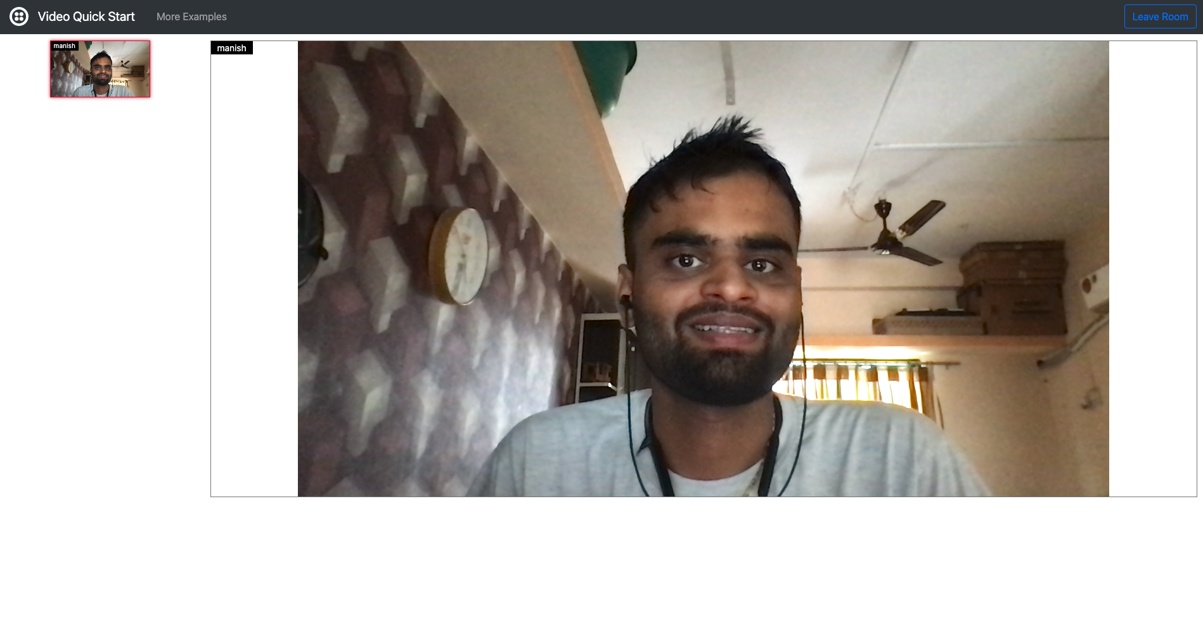

Max Audio Bitrate (bps) : 16000

Max Video Bitrate (bps) : 64000

Please refer screenshot Ex-1.1 and Ex-1.2

Room SID : RMa0d5808031adef44ab62105bfa6bb433

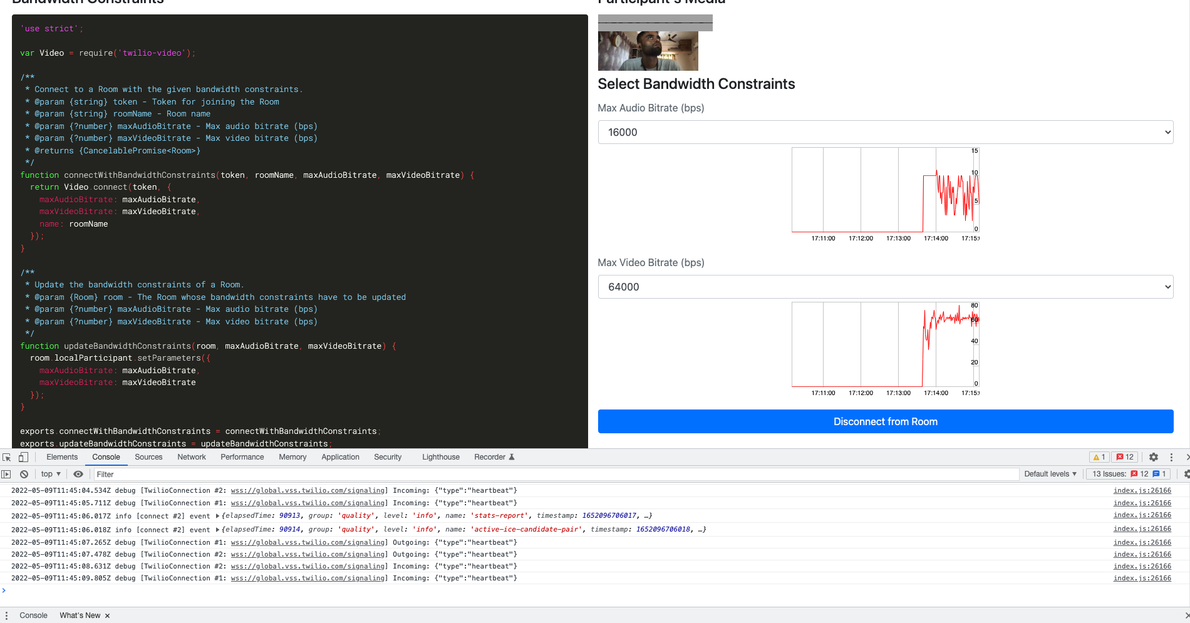

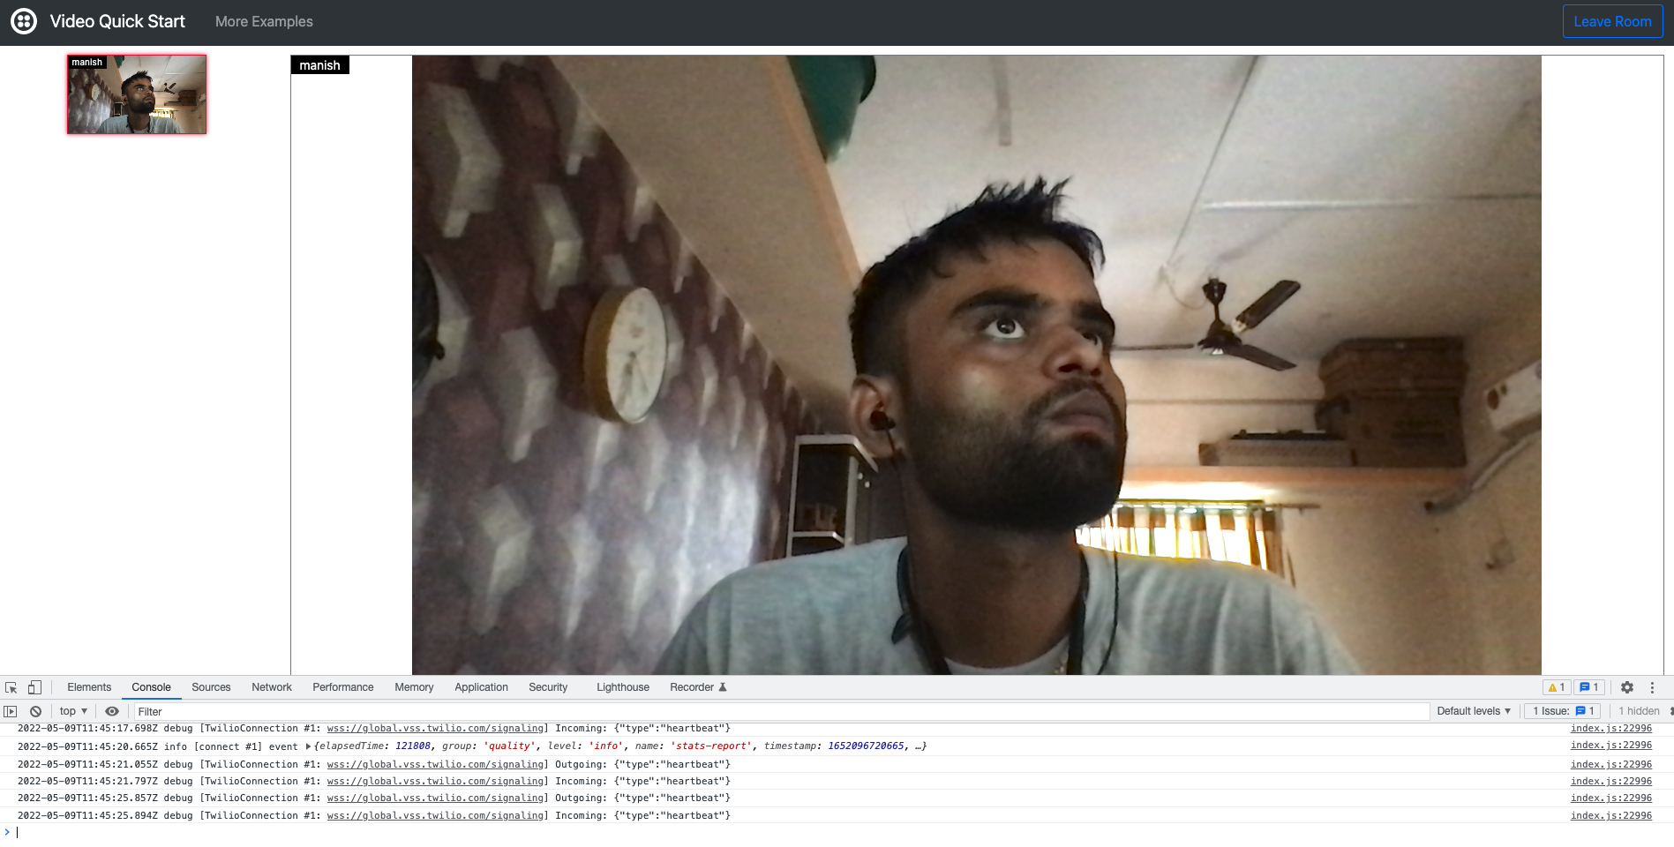

Max Audio Bitrate (bps) : 32000

Max Video Bitrate (bps) : 128000

Please refer screenshot Ex-2.1 and Ex-2.2

Room SID : RM69f85ef0819974f63e35edb8e4153f73

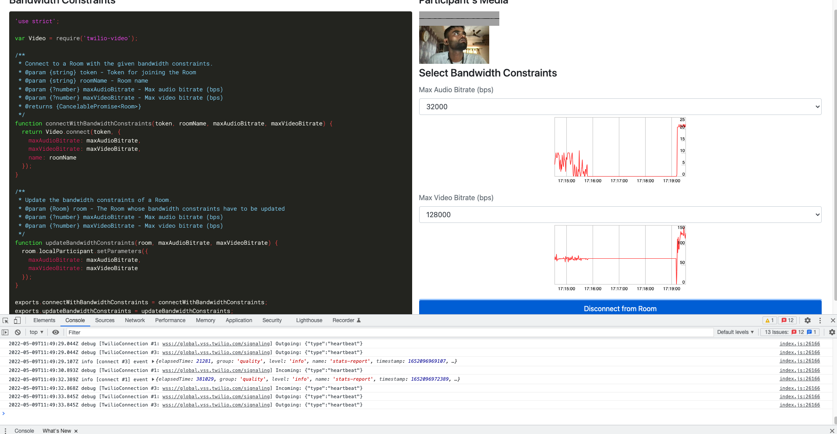

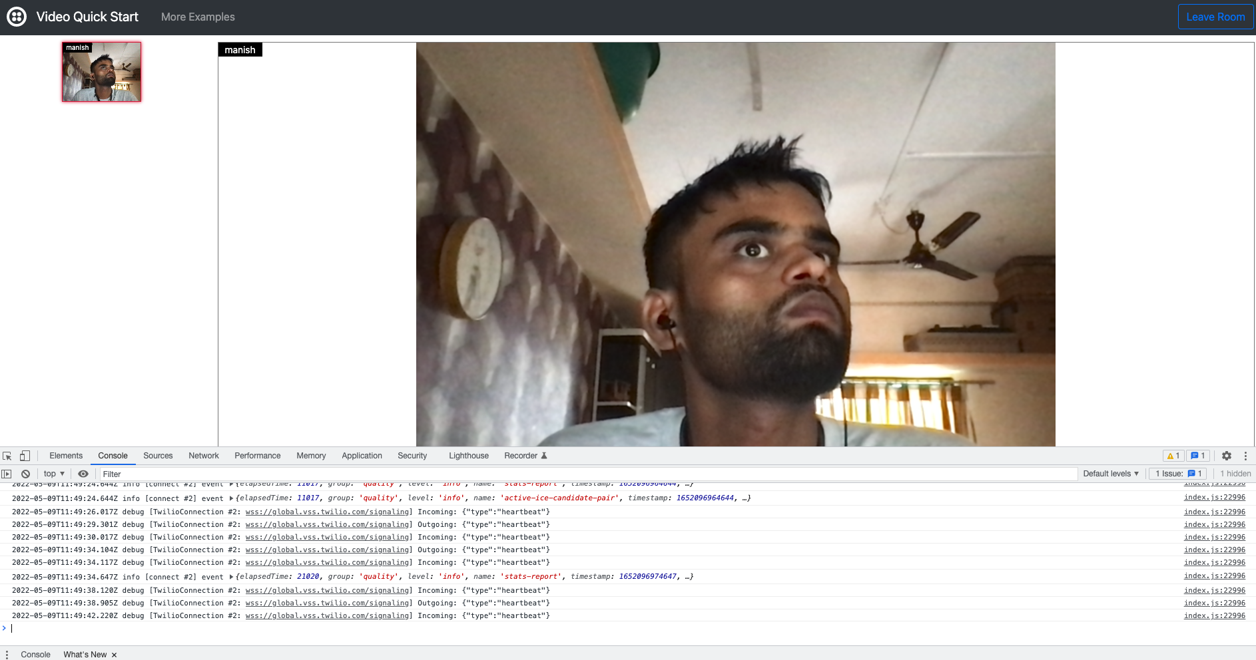

Max Audio Bitrate (bps) : 64000

Max Video Bitrate (bps) : 256000

Please refer screenshot Ex-3.1 and Ex-3.2

Room SID : RMdc698daf8c117eb881243d730cf39700

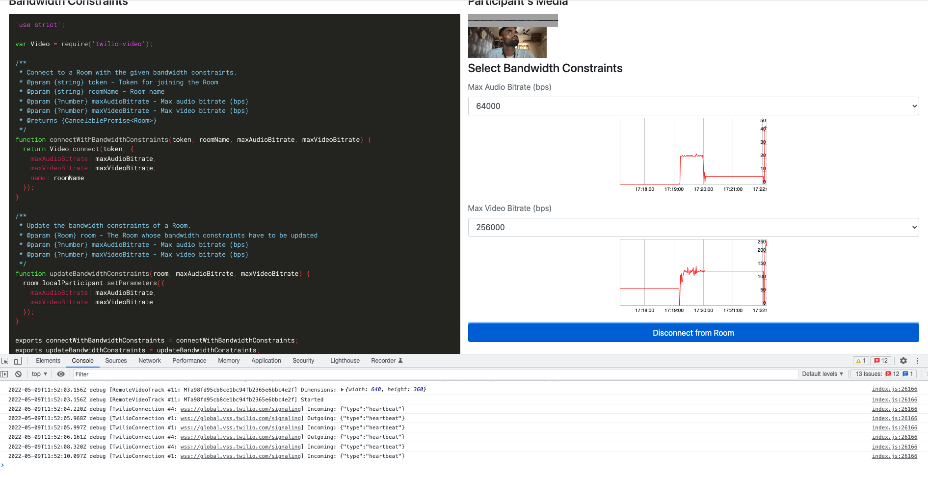

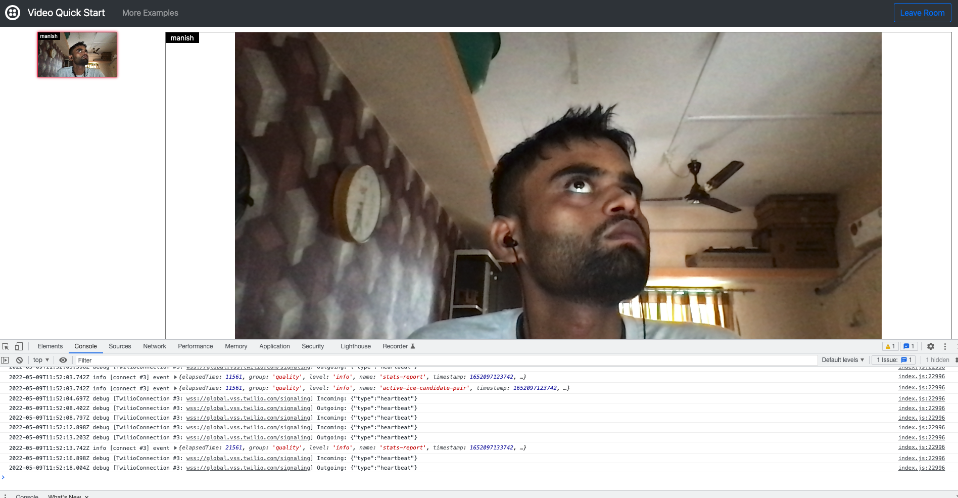

Max Audio Bitrate (bps) : 64000

Max Video Bitrate (bps) : 512000

Please refer screenshot Ex-4.1 and Ex-4.2

Room SID : RM393028329ca7425ea99df5aa49c81a82

